$$Every one should write one blog on AI$$

$$scope of AI in educa, man,agri,$$

$$AI in Tech$$

$$EDA ===ML-DL-NLP-GenAI====Per===Depl$$

$$Traditional models vs generative ai models$$

$$what are the starting to till now developments in Deep learning$$

$$First model name as Deep le:$$

$$CNN==== ? === ? === ?$$

$$story tellers$$

$$Step-1:Read the data$$

$$step-2:Preprocess or EDA$$

$$Step-3:ML model development$$

$$Step-4:Evaluation$$

$$Step-5:Tuning$$

$$Step-6:Deployment$$

$$ML model development$$

$$Supervised : Target column avaliale$$

$Target label has numerical: Regression$

$Linear regrssion$

$Make the equation$

$Goal : Find the suitable coeff, in order reduce the error$

$OLS$

$interpretation$

$RSE:Lack of fit$

$R_{Squared}=Good ness of fit$

$Adjusted R_{squared}$

$Hypothesis$

$P<alpha: Reject the Null hypothesis$

$Assumptions$

$Target label has categorical$

$Logistic regression$

$Probability equation$

$sigmoid function$

$Interpretation$

$Linear form Logistic regression$

$Log odds ratio$

$Decision Tree$

$Information gain : Entropy$

$Entropy of the variable$

$Total entropy$

$Gain of the variable$

$Draw back there with ID column$

$Gain ratio$

$ID3 and C4.5$

$Impurity: Gini$

$Naive bayes$

$Multiplication$

$independent case$

$Conditional probability$

$P\left(\frac{Y}{X}\right)$

$Y has two yes and No$

$Class conditional independence$

$Laplacian correction$

$KNN$

$Perfomance metrics$

$Python code$

$Ensemble methods$

$SVM$

$K-means$

$Heirarchical$

$$How the data divided$$

$$train test train error over under normal bias varoance$$

$$OLS gradient descent$$

$$ERROR cost loss graphs$$

$$Probabilies logits$$

$$K-Nearest Neighbours$$

$$Math: Euclidian distance$$

$$\left(x_{1},y_{1}\right) \left(x_{2},y_{2}\right)= \sqrt{{\left(x_{2}-x_{1}\right)}^{2}+{\left(y_{2}-y_{1}\right)}^{2}}$$

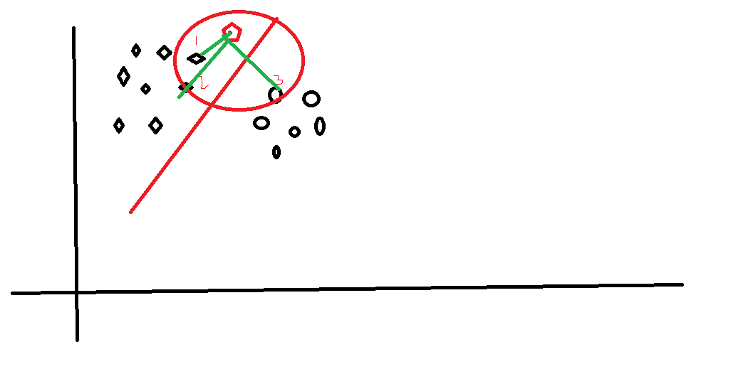

$$In the K nearest neighbours, It selects the Neigbours based on Distance$$

$$Calculate the distance between new data point to all other data points$$

$$Distance is more means, relation is less vice versa$$

$$After calculate the distance will provide the ranking based on distances$$

$$Assume that we have 5 data points are there$$

$$will caculate distance betwen new data point 6 with all other data points \left(5\right)$$

$$d_{16},d_{26},d_{36},d_{46},d_{56}$$

$$Now rankning wil go from 1 to 6$$

$$Out of these 6 ranks , now you will select only some data ponits$$

$$That data points are your neighbours$$

$$Selecting Neigbours completely user wish$$

$$It is called as Hyper parameter , K is a hyper parameter$$

$$OLS b_{o} b_{1} provide by model \left( parameters\right)$$

$$hyper parameter means user can change the parameters to get the good model performance$$

$$every algorithm has some hyper parameters$$

$$that parameters user will change , to get good model performance$$

$$that is called a hyper parameter tuning$$

$$DT : entropy Gini$$

|  |  |  |
| --- | --- | --- |
| X1 | X2 | Y |
| 7 | 7 | Bad |
| 7 | 4 | Bad |
| 3 | 4 | Good |
| 1 | 4 | Good |

X1=3 and X2=7 y?

$$Step-1:Calcculate the distance$$

$$\left(7,7\right) vs \left(3,7\right)=\sqrt{{\left(3-7\right)}^{2}+{\left(7-7\right)}^{2}}=\sqrt{16}$$

$$\left(7,4\right) vs \left(3,7\right)=\sqrt{{\left(3-7\right)}^{2}+{\left(7-4\right)}^{2}}=\sqrt{25}$$

$$\left(3,4\right) vs \left(3,7\right)=\sqrt{{\left(3-3\right)}^{2}+{\left(7-4\right)}^{2}}=\sqrt{9}$$

$$\left(1,4\right) vs \left(3,7\right)=\sqrt{{\left(3-1\right)}^{2}+{\left(7-4\right)}^{2}}=\sqrt{13}$$

$$Step-2:$$

|  |  |  |  |
| --- | --- | --- | --- |
| X1 | X2 | Y | Distance |
| 7 | 7 | Bad | $$\sqrt{16}$$ |
| 7 | 4 | Bad | $$\sqrt{25}$$ |
| 3 | 4 | Good | $$\sqrt{9}$$ |
| 1 | 4 | Good |  |

|  |  |  |  |  |
| --- | --- | --- | --- | --- |
| X1 | X2 | Y | Distance | Rank |
| 7 | 7 | Bad | $$\sqrt{16}$$ | 3 |
| 7 | 4 | Bad | $$\sqrt{25}$$ | 4 |
| 3 | 4 | Good | $$\sqrt{9}$$ | 1 |
| 1 | 4 | Good | $$\sqrt{13}$$ | 2 |

|  |  |  |  |  |  |
| --- | --- | --- | --- | --- | --- |
| X1 | X2 | Y | Distance | Rank | Neigbour |
| 7 | 7 | Bad | $$\sqrt{16}$$ | 3 | Yes |
| 7 | 4 | Bad | $$\sqrt{25}$$ | 4 | ------- |
| 3 | 4 | Good | $$\sqrt{9}$$ | 1 | Yes |
| 1 | 4 | Good | $$\sqrt{13}$$ | 2 | Yes |

|  |  |  |  |  |  |  |
| --- | --- | --- | --- | --- | --- | --- |
| X1 | X2 | Y | Distance | Rank | Neigbour | Original y |
| 7 | 7 | Bad | $$\sqrt{16}$$ | 3 | Yes | Bad |
| 7 | 4 | Bad | $$\sqrt{25}$$ | 4 | ------- |  |
| 3 | 4 | Good | $$\sqrt{9}$$ | 1 | Yes | Good |
| 1 | 4 | Good | $$\sqrt{13}$$ | 2 | Yes | Good |

$$Step-6:$$

$$Neigbours outputs are : \left\{B,G,G\right\}$$

$$Take the majority voting :Good$$

$$If the outputs numerical :Take the average$$

$$Qn) How to choose K$$

$K:Hyper parameter:User will decide$

$K= \sqrt{number of observation}$

$K=always an odd number$

$$In this particular exacmple: n=4$$

$$K= \sqrt{4}=2 either 2+1 or 2-1 3 or 1$$

$$what happens if k=1?$$

$$k=1 then model will be overfit$$

$$k=n : model will underfit$$

$$IN DT when the model will overfit$$

$$IN NB when the model will overfit$$

$$IN LR when the model will overfit$$

$$In Knn when the modle will overfit$$